SYSC 3010 A: Project Proposal

Line-Following Assistive Device (L.A.D.)

**September 23rd, 2019**

**Group W2**

Proposal By: Denise Mayo, Brannon Chan, Zachary Porter, and Erdem Yanikomeroglu

**Background and Objective**

For persons with disabilities who may not always have a primary caregiver in their home, smart assistance technology is invaluable. Robotic assistance can help both persons living with mobility issues and their caregivers by providing assistance with simple tasks for the disabled party and allows the caregiver to perform other tasks without having to worry about doing the small things.

# Proposed Solution

We shall demonstrate a simple prototype of one type of assistance robot. This robot will be able to do the following things:

1. Be able to move in front of a table by tracking and following a line on the floor
2. Be able to pick up small objects from a table, where the items shall weigh no more than 100g
3. Be controlled by an android app
4. Relay commands and data to & from the central database

# 

# 

# Technical Specifications

The robot will be implemented in the following stages.

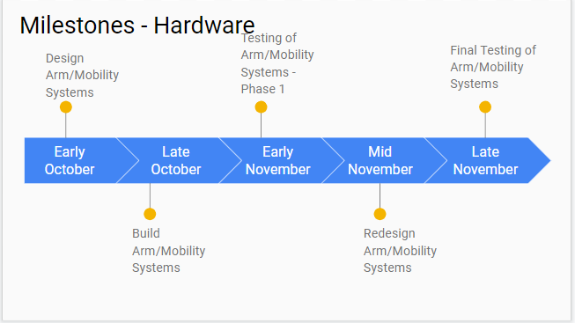

Figure 1: Projected milestones for development of hardware components of the arm and mobility systems

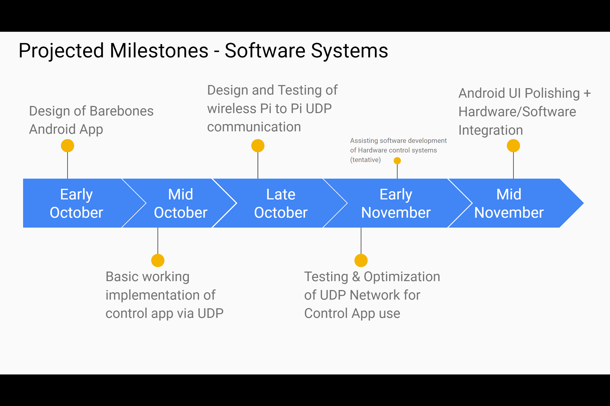

Figure 2: Projected milestones for development of software components of the database and android app

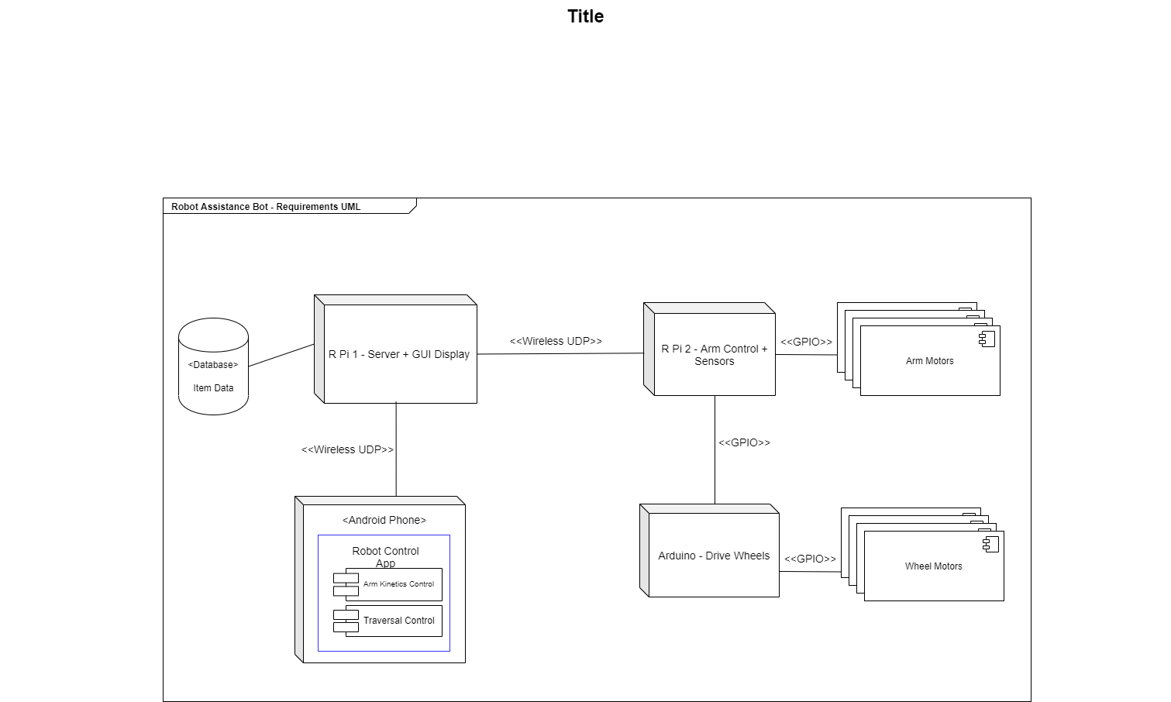

Figure 3: High level UML diagram of L.A.D. implementation

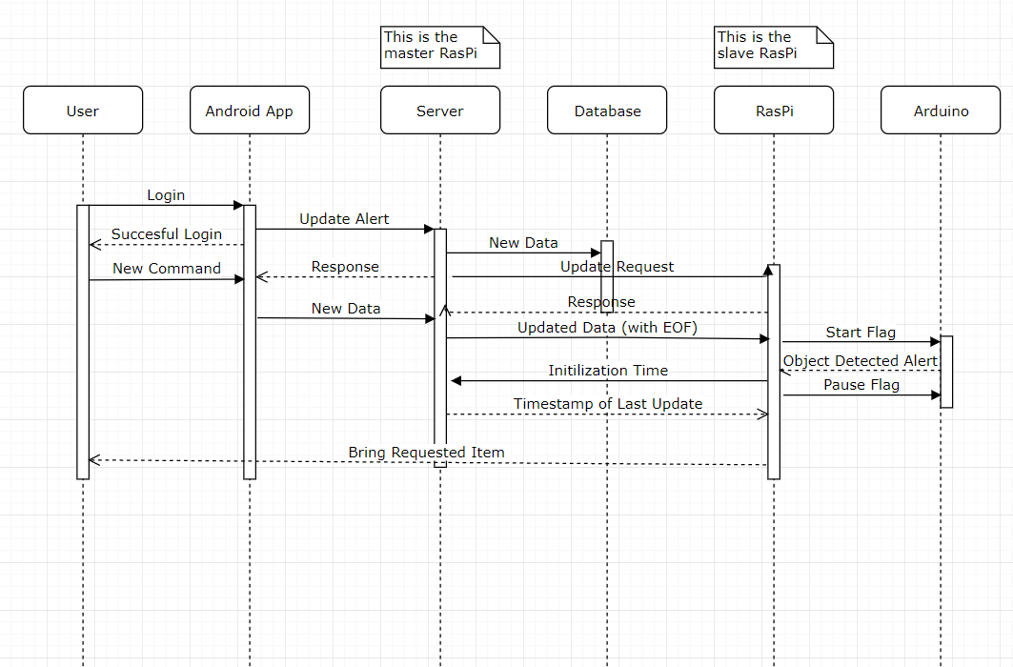

Figure 4: Sequence Diagram of L.A.D. implementation

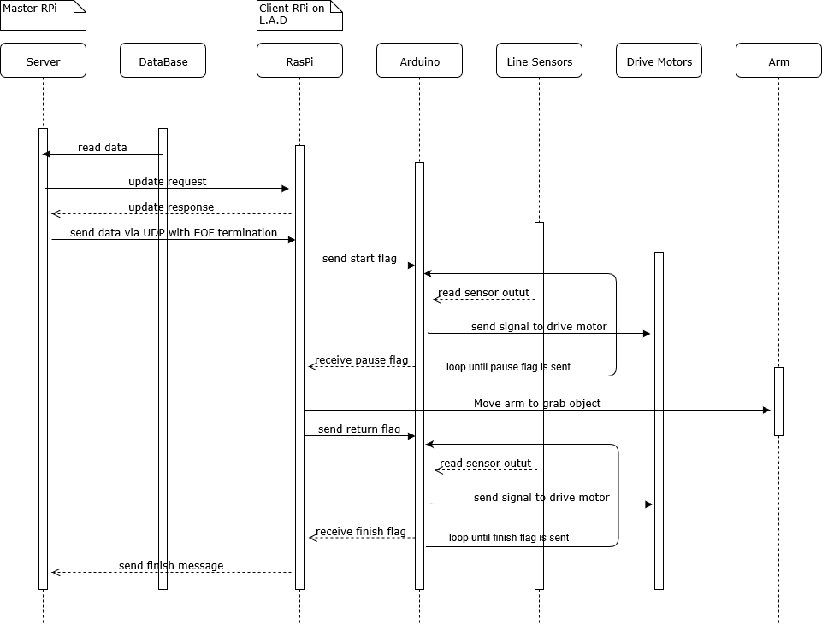

Figure 5: Sequence Diagram for Raspberry Pi to Arduino interaction on the L.A.D

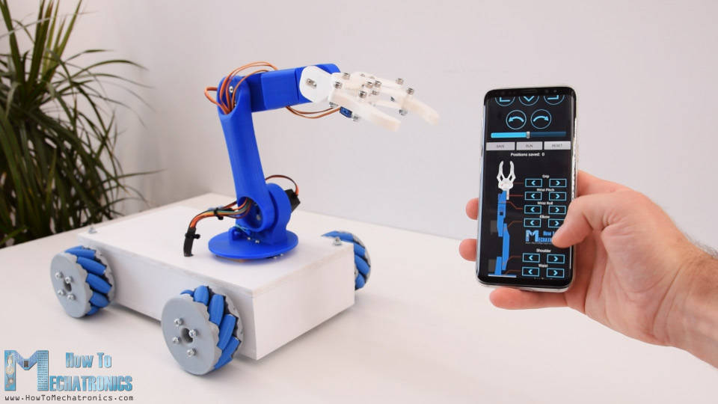

Figure 6: Diagram of how the L.A.D is expected to appear [3]

**Project Development Roles**

1. Line-Following Algorithm & Detection- Denise and Zachary
2. Assistance Arm Mechanical Articulation - Denise and Zachary
3. LineBot - Database Communication - Erdem, Zachary, Brannon
4. L.A.D. Control via Android user interface - Erdem and Brannon
5. QR Code Reader (tentative) - Zachary

**L.A.D System Testing Plan**

The testing plan for the L.A.D. system will be as follows:

**Mobility System:**

The mobility system, which will involve interaction between a Pi and an Arduino, will be tested incrementally. The first step in testing will be getting the Arduino to drive the wheels. After this adding sensors to detect lines will be important, and finally adding the Pi and testing that the two boards can communicate will be essential. The Pi will be in charge of getting data from the server, controlling the arm, and telling the arduino what to do. The Arduino will simply be there to drive the L.A.D. the Arduino will implement our line following algorithms, and drive the wheels.

**Arm System:**

The arm will be tested incrementally, first to establish the intended movement of the arm vertically and rotationally, and then to slowly increase articulation and desired pressure of the hand attachment. Load testing will be performed on the hand to determine the required grip strength of the hand on various sized objects. The weight of the objects will begin around 20g, and increase by approximately 10-15g until 100g is reached, time of final demonstration arrives, or the hand attachment fails in some way.

**Database:**

The database will need to be tested on both the server and the L.A.D. the server stores all data in a database file so even if the system shuts down no data is lost. On the L.A.D there will be a local cache that will work similarly to the database, and is intended to allow the L.A.D to finish its task even if connection to the server is lost. The tests for the database will consist of ensuring data can be transmitted back and forth between the server and the L.A.D. the next step of the tests will involve ensuring data can be read/written to the server database, encoded and sent via UDP, received and decoded on the L.A.D, and written to the L.A.D’s cache. Finally, speed tests can be performed on different encoding types, and on different methods of transmitting data to find the fastest method.

**Android App:**

A user friendly Android app will be created to allow for easy wireless manual control of the L.A.D. This simple, easy to use interface will also allow non-technical users to set up, create or change automated commands issued to the L.A.D; enabling the system to autonomously assist around the house without having the caregiver controlling it

The L.A.D Control App will feature multiple pages for the user:

* Home Page: A simple welcome page the user sees upon opening the app, will allow the user to log into their account and then select from a list of users' L.A.D’s to configure/use.
* Manual Control: This page allows the user to tell the L.A.D to traverse the line forwards or backwards, to stop, and to manually articulate the Arm System via a digital joystick.
* Settings: After selecting a L.A.D on the home page, the user can change configure the L.A.D, change its’ name, when it’s active hours are (i.e: when the L.A.D can enter sleep mode), and other advanced options (for technical/developer use only).
* Automate: Allows the user to create and edit custom commands for the L.A.D. These commands will be created from a list of the L.A.D’s functions, and other simple drag-n-drop style actions/logic. The L.A.D will execute these custom commands at a defined time, in the sequential order the user specified.

**References and Citations**

[1] C. Toporov, "Line following robot with OpenCV and contour-based approach", *Medium*, 2019. [Online]. Available: https://medium.com/@const.toporov/line-following-robot-with-opencv-and-contour-based-approach-417b90f2c298. [Accessed: 29- Sep- 2019].

[2] "Arduino Line Follower Robot Code and Circuit Diagram", *Circuitdigest.com*, 2019. [Online]. Available: https://circuitdigest.com/microcontroller-projects/line-follower-robot-using-arduino. [Accessed: 30- Sep- 2019]

[3] "Store and replay this robot’s movements from your phone", *Arduino Blog*, 2019. [Online]. Available: https://blog.arduino.cc/2019/07/08/store-and-repeat-this-robots-movements-from-your-phone/. [Accessed: 30- Sep- 2019].